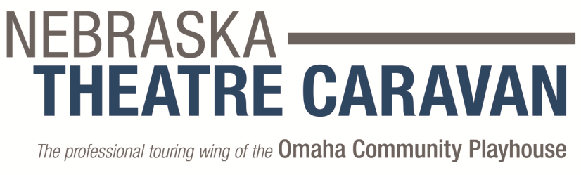

PRESS RELEASE
FOR IMMEDIATE RELEASE
Date
Media Contact: Name
Title
Email | Phone

A CHRISTMAS CAROL
by Charles Dickens
Adapted for the stage by Charles Jones
Musical arrangements by John Bennett
City, State - Theatre presents Charles Dickens’ most beloved holiday story, A Christmas Carol, as you’ve never seen it before, show dates.
This celebrated Charles Jones adaptation of Charles Dickens’ A Christmas Carol from Nebraska Theatre Caravan is rich with thrilling ensemble music, alive with color and movement and is created to tell this great and enduring tale in a manner that people of all ages will enjoy. Woven throughout this classic tale are beautiful new arrangements and moving renditions of holiday songs such as God Rest Ye Merry Gentlemen, Wassail Wassail, Good Christian Men Rejoice, Away in a Manger, Greensleeves, The Boar’s Head Carol and many more. Featuring a cast of 23 performers, live musicians, and Broadway-style scenery and costumes, audiences cherish this sumptuous holiday classic. ﻿
In this adaptation for the stage, one actor plays Ebenezer Scrooge. Each of the 23 member ensemble supports both the story and the music with exceptional ensemble singing and dancing, while each taking on a significant character as the story unfolds. The current directors and designers of this production do not attempt to stray from Charles Jones’ original concept. As stewards of the production they strive to convey to each company of players the integrity and the magic that are intrinsic to the piece.﻿
Production: A Christmas Carol
Show dates: show information
Location: theatre information
Tickets: ticket prices and how to purchase tickets
Sponsored by: sponsor information
Media Note: Theatre reviewers from the media are encouraged to attend opening weekend. Contact name, phone, or email for complimentary ticket(s) and press packet.

